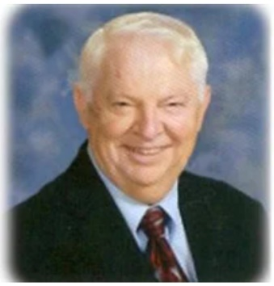
In Memoriam

Stephen G. Dressler, Sr., 83 years, of Columbia, IL, passed away on July 26, 2023. He was born April 24, 1940, in Yugoslavia, son of the late Joseph, and Magdalena, nee Schmidt, Dressler. He was married to Joyce, nee Dunning, Dressler, who survives him. Steve was a member of Immaculate Conception Catholic Church and consummate member of the Knights of Columbus - Council 6165 - 4th Degree since 1988. He worked tirelessly for the Church and the [Knights of Columbus as Membership Director and past District Deputy, among others], the St. Vincent de Paul Society, and also as a soccer coach for I.C.S., among numerous other positions and projects. He had retired from Centerre Bank, St. Louis, MO, where he had worked in bank operations. Steve enjoyed fishing, coaching soccer, was a St. Louis Blues fan, and loved flower gardening in his yard.

Surviving are his sons, Stephen (JoAnn) Dressler Jr. of Barnhart, MO, Tony (Gina) Dressler of Tampa, FL; grandchildren, Christopher Dressler, Michael Dressler, Elena Dressler, Elissa Dressler, A.J. Dressler, Eli Dressler, Amanda Shope, and Anna Dressler; nine great-grandchildren; sister, Rosina (Andy) Belt of Brookville, OH, along with other relatives and friends. He was also preceded in death by a brother, Joseph Dressler.

In lieu of customary remembrances, the family requests with gratitude that memorial contributions be directed to: Immaculate Conception Catholic Education & Activities Center Building Fund, 411 Palmer Road, Columbia, IL 62236, St. Vincent de Paul Society of Immaculate Conception Church, or Promedica Hospice, 333 Salem PL - Suite 150, Fairview Heights, IL 6220.

Courtesy of Leesman Funeral Home

Steve Dressler was responsible for bringing many of the current and deceased Knights into the order. He was mentor, friend, and true brother to all the Knights. We mourn our loss, but are confident that Jesus will welcome him with open arms and proclaim, “Well done, my good and faithful servant.”
Queen of Hearts Raffle
Immaculate Conception Parish will be the beneficiary of a Queen of Hearts raffle taking place on Tuesday evenings starting July 11th at Sunset Overlook, 11604 Bluff Rd. in Columbia. The various ministries and parish organizations have been asked to donate time to sell Queen of Hearts tickets and 50/50 raffle tickets. The council has accepted the request and will staff the raffle on Tuesday, August 8th and Tuesday, August 22nd, from 4pm until 7:30. Click here to sign-up online via Sign-up Genius to volunteer for any slots that are available on any day(s) you would like to volunteer. This is an ongoing fund-raising event that will need volunteers long into the future. Please consider helping the cause.
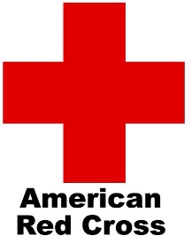
Blood Drive
We had 31 donors attempt to donate and collected 27 units of blook on July 7th. Thanks to all those who attempted to give and thanks to James Huch for organizing this life saving event for us every other month. The next blood drive will be held on Friday, September 8, 2023, from 8am until 1pm. Invite your family and friends, and come give the gift of life.
Fr. Carl’s Jubilee Celebration
Father Carl will celebrate his 50-year jubilee on Sunday, September 17th at 11am Mass at Immaculate Conception Church, with a reception immediately following in the Michael L. Kish Gymnasium and Theatre. The Knights have committed to help set up, park cards, staff the drink station, and aid in the clean-up efforts after. Sign-up sheets will be posted on our website and links to them will be sent via email at a later date. Please show your appreciation for all that Father Carl has done for us by giving generously of your time.

August 26th Hamburger Stand
The July 4th event at the American Legion was cancelled due to the severe weather that disrupted power to most of Columbia and the surrounding area for days. It has been rescheduled for Saturday, August 26th, from 4pm until 8:30. We will need Knights and friends to help cook, prep, and sell hamburgers, drinks, and Ted Drewes that day. Click here to sign up online or contact Jim VonDerHaar at gk@kofc6165.org if you can help.

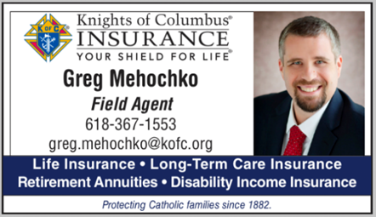
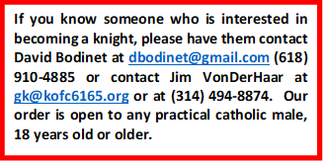
Major Degree Exemplification and Fr. McGivney Mass
We will host a Major Degree Exemplification on Thursday, August 10th at 6pm at Immaculate Conception Church. We will also celebrate Mass in honor of the Venerable Fr. Michael J. McGivney immediately after at 7pm. Afterward, we will retire to the garden level for refreshments and fellowship. Everyone is invited to attend Mass and the exemplification, including members from surrounding councils. Contact GK Jim VonDerHaar if you would like to participate in the Mass as lector, minister of hospitality, offertory, singer, musician, etc.

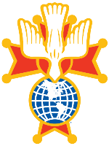
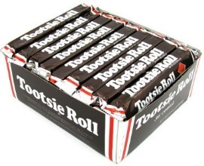
2023 Knights of Columbus Car Show
The 2023 Knights of Columbus Car Show will be on Saturday, October 7th, 2023 come rain or shine. See the great cars and listen to good music while enjoying a variety of food and drinks. It costs nothing to walk the show, $15.00 to display your car, $20.00 if you want your entry judged by the Give Back Pack. Registration opens at 8am, show starts at 11. Click here to sign up online to work the show, or click here to register to display your vehicle(s).

Pathfinders Scripture Discussion
Pathfinders is a group of men who meet on Saturdays at 7:30am to read and discuss the Sunday scriptures. We start with music and prayer, read the readings for the Sunday Mass, and discuss what the Holy Spirit brings to light. They are always finished in an hour. Come join us this Saturday to see what it’s all about.
4th Degree Restaurant Raffle
The local Knights of Columbus 4th Degree Assembly 1529 is selling tickets for a 12-month Restaurant Raffle. Each winner will receive a $250 gift card to the sponsored restaurant of the month. Alternatively, the winner can elect to receive $200 in cash. The drawings will happen on the 3rd Wednesday of each month beginning October 2023. All winning tickets are re-entered for subsequent monthly drawings. Only 400 tickets will be sold at a cost of $20.00 each. For tickets contact Wes Hoeffken at hoeffken@htc.net or any other KC 4th Degree member. The Assembly will also be selling tickets after all masses the weekend of September 30/October 1.
Intellectual Disabilities Drive
This year’s Tootsie Roll Drive will be held the weekend of September 15th and 16th. Please put it on your calendar and look for sign-up sheets online soon.

Thanks!!!
June Continuous Years of
Service as a Knight

Richard F Sambo | 64
Michael L Kish | 55
Eugene C Gilbreth | 54
Eugene R Toenjes | 54
Lawrence R Toenjes | 54
Larry G Greenfield | 49
Brian S Sminchak | 36
Jason P Tucker | 26
Raymond O Farley | 26
Kevin L Bragg | 14
William J Feldker | 14
Michael E Schaefer | 14
Michael P Stark | 14
Anthony J Traxler | 14
Paul M Smith | 8
Larry J Buhr | 1

